“RESEARCH CONTENT”

Project Report submitted for the partial fulfilment of grade for the course

Data Structures and Algorithms -3 (25CS2103E)

in

DEPARTMENT OF COMPUTER SCIENCE ENGINEERING

by

AKSHAYA TATI :2520030143

R.JUHIT NAIDU :2520030457

M.SANJITH RAJ :2520030463

Team Number:16
Section:02

Under the Guidance of

Dr. S. Vinay Kumar
Associate Professor
Department of Computer Science and Engineering





2026-27

DEPARTMENT OF COMPUTER SCIENCE ENGINEERING

Declaration

The Project Report entitled “Title of the Project” is a record of Bonafide work of AKSHAYA TATI – 2520030143, R.JUHIT NAIDU – 2520030457, M.SANJITH RAJ – 2520030463 submitted in partial fulfillment for the award of B. Tech in Computer Science and Engineering. The results embodied in this report have not been copied from any other departments/University/Institute.

AKSHAYA TATI– 2520030143
R.JUHIT NAIDU – 2520030457
M.SANJITH RAJ – 2520030463

DEPARTMENT OF COMPUTER SCIENCE ENGINEERING

CERTIFICATE

This is certify that the mini project based report entitled “Title of the Project” is a bonafide work done and submitted by AKSHAYA TATI – 2520030143, R.JUHIT NAIDU – 2520030457, M.SANJITH RAJ – 2520030463 in partial fulfillment of the requirements for the award of the degree of BACHELOR OF TECHNOLOGY in Department of Computer Science Engineering, during the academic year 2026-27.

Signature of the Guide Signature of the HOD
(Dr. S. Vinay Kumar)

Signature of the External Examiner
ACKNOWLEDGEMENT

Description in Times New Roman font 12 size with two to three paragraphs thanking guide Dr. S. Vinay Kumar, Associate Professor, Dept. of CSE and Dr. P. Venkateshwara Rao, Associate Professor, HOD CSE

AKSHAYA TATI– 2520030143
R.JUHIT NAIDU – 2520030457
M.SANJITH RAJ – 2520030463

Abstract

The Research Paper Pattern Search System Using String Matching Algorithms is designed to search research papers efficiently using keywords and text patterns.It provides a searchable collection of research documents organized into multiple batches.The system helps users locate relevant information without reading every paper manually.Users can enter a keyword or phrase to search across the available research documents.The system identifies the documents that contain the given search pattern.It aims to make research paper searching faster, simpler, and more organized.
The project implements several algorithms, including Knuth-Morris-Pratt (KMP), Z Algorithm, Suffix Array, Edit Distance, and Aho-Corasick.These algorithms demonstrate different approaches to string matching and text processing.The system uses the KMP algorithm as the primary method for searching patterns in the research corpus.It also demonstrates graph algorithms such as Edmonds-Karp and Vertex Cover approximation.A randomized search demonstration is included to explore sampling-based search techniques.These implementations help illustrate the practical application of Data Structures and Algorithms.
The system displays matching research documents along with the number of occurrences and their positions in the text.Search results can be saved to a file for future reference and analysis.The project provides a simple way to explore research content based on specific keywords.It reduces manual effort and improves the accessibility of information within the document collection.The implementation also supports testing and understanding individual algorithms through separate test programs.Overall, the project demonstrates how algorithmic techniques can support efficient research information retrieval.

Table of Contents

 |  |  | Page No.
 | Acknowledgement
 | Abstract
 | Table of Contents
 | List of Figures
1 | Introduction | 1.1 Overview  1.2 Problem statement  1.3 Scope of the project  1.4 Objectives | 2-3
2 | System Requirements | 2.1 Functional Requirements  2.2 Non-Functional Requirements | 3-4
3 | System Design | 3.1 High-level Architecture Diagram  3.2 Description of each layer | 4-7
4 | Implementation | 4.1 Module-wise implementation  4.2 Front-end logic (UI rendering, state management)  4.3 API integration | 7-13
5 | Results |  | 13-14
6 | Challenges & Limitations | 6.1 Issues faced during development  6.2 Solutions applied  6.3 Limitations of the System | 15-17
7 | Conclusion & Future Work | 7.1 Conclusion  7.2 Future Work  7.3 Skills learned during development | 18-20
 | References | - Books, tutorials, APIs, documentation sites used | 20-21

List of Figures

1.1 Block Diagram of the Research Paper Pattern Search System
1.2 Components of the Research Paper Pattern Search System
1.3 Flowchart Showing the Working of the Proposed System
1.4 Phases of the Research Paper Search Process
1.5 KMP-Based Research Paper Pattern Searching
1.6 Z Algorithm-Based Pattern Searching
1.7 Suffix Array-Based Pattern Searching
1.8 Edit Distance-Based Text Comparison
1.9 Aho-Corasick Multiple Pattern Matching
1.10 Edmonds-Karp Maximum Flow Algorithm
1.11 Vertex Cover Approximation Algorithm
1.12 Monte Carlo Search Demonstration
1.13 Research Paper Corpus Organization
1.14 Keyword Search Results Display
1.15 Search Results Saved to a File

- INTRODUCTION

1.1 Overview
The diagram shows how a user enters a search keyword, how the system processes it against the research paper corpus using the implemented algorithms, and how matching documents, occurrence counts, and pattern positions are displayed. Search results can also be saved to a file.
Important: Edmonds–Karp, Vertex Cover, and Monte Carlo Search are separate algorithm demonstrations in your project, not part of the main KMP search pipeline. If your report requires a strictly accurate system architecture, show these in a separate Additional Algorithm Demonstrations box rather than implying they all process the main search query.

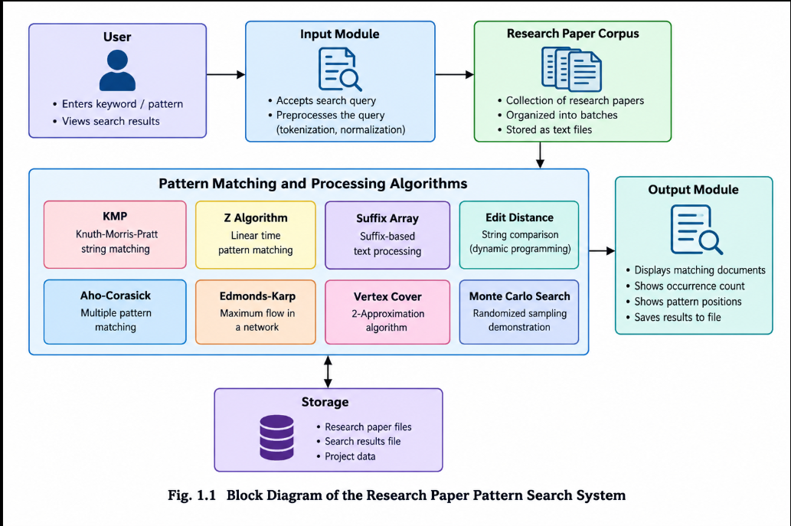

1.2 Problem Statement

Research papers contain large amounts of information, making it difficult and time-consuming to locate specific keywords or phrases manually. Searching through multiple documents individually increases the effort required to identify relevant information and determine where a particular pattern occurs. Therefore, an efficient system is needed to search a collection of research papers and retrieve matching content quickly.
The Research Paper Pattern Search System Using String Matching Algorithms aims to address this problem by organizing research papers into a searchable corpus and applying suitable algorithms to identify user-provided patterns. The system uses the Knuth-Morris-Pratt (KMP) algorithm as its primary search method and includes other algorithm implementations to demonstrate different computational techniques.
The proposed system displays the matching documents, the number of occurrences, and the positions of the searched pattern. It also supports saving search results for future reference. The main goal is to reduce manual searching effort, improve information retrieval, and demonstrate the practical application of Data Structures and Algorithms in text processing.

1.3 Objectives
The main objective of the Research Paper Pattern Search System Using String Matching Algorithms is to develop an efficient system for searching research papers using keywords and text patterns. The specific objectives are:
Efficient Pattern Searching: To search for specific keywords and phrases within research papers using string-matching algorithms.
Implementation of Algorithms: To implement algorithms such as KMP, Z Algorithm, Suffix Array, Edit Distance, and Aho-Corasick for text processing and pattern matching.
Organized Document Management: To maintain a collection of research papers organized into batches for convenient access and retrieval.
Accurate Search Results: To identify matching documents and display the number of occurrences and positions of the searched pattern.
Result Storage: To save search results in a file for future reference and analysis.
Algorithm Demonstration: To demonstrate additional algorithmic techniques, including Edmonds-Karp, Vertex Cover approximation, and randomized sampling-based search.
Reduced Manual Effort: To minimize the time and effort required to locate relevant information across multiple research documents.
Practical Learning: To demonstrate the practical application of Data Structures and Algorithms in text searching, processing, and information retrieval.

1.4 Scope of the Project
The scope of the Research Paper Pattern Search System Using String Matching Algorithms is to provide an efficient and organized method for searching research papers based on keywords and text patterns. The system works with a collection of text-based research documents stored in multiple batches and allows users to locate relevant information without manually reading every document.
The project primarily focuses on implementing and demonstrating string-matching and text-processing algorithms, including Knuth-Morris-Pratt (KMP), Z Algorithm, Suffix Array, Edit Distance, and Aho-Corasick. The KMP algorithm is used as the primary search technique in the main application. Additional implementations, such as Edmonds-Karp, Vertex Cover approximation, and Monte Carlo Search, demonstrate other algorithmic concepts.
The system provides matching document names, occurrence counts, and pattern positions. It also supports saving search results to a file and testing individual algorithms through separate Java programs. These features make the project useful for understanding algorithm performance and practical text retrieval.
The current scope is limited to text files and command-line interaction. It does not include a full web interface, automatic research-paper downloads, semantic searching, or advanced document ranking. In the future, the system can be extended with a graphical user interface, PDF processing, advanced search filters, relevance-based ranking, and larger document collections.

2.1 Functional Requirements

The system should provide the following functionalities:
- Load research paper text files from the corpus directory.
- Accept keywords or phrases from the user.
- Search for patterns using the KMP algorithm.
- Display matching document names, occurrence counts, and pattern positions.
- Save search results in a text file.
- Execute individual algorithm test programs.
- Handle invalid or empty search patterns appropriately.

2.2 Non-Functional Requirements
The system should satisfy the following quality requirements:
- Efficiency: Perform pattern searching efficiently across the available text documents.
- Accuracy: Report matching positions and occurrence counts correctly.
- Usability: Provide simple command-line interaction.
- Maintainability: Organize Java source files into separate classes for easier modification.
- Portability: Support operating systems with a compatible Java environment.
- Reliability: Process available documents and save search results consistently.
3.1 High-level Architecture Diagram
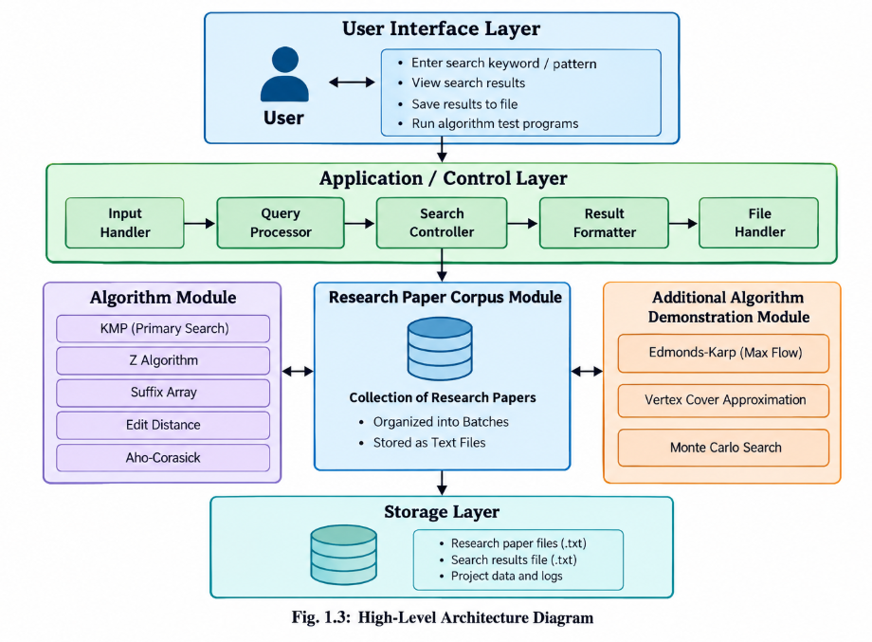

The architecture consists of five main parts:
User Interface Layer: Accepts search keywords and displays results.Application / Control Layer: Handles input, query processing, search control, result formatting, and file operations.Algorithm Module: Contains KMP, Z Algorithm, Suffix Array, Edit Distance, and Aho-Corasick.Research Paper Corpus and Additional Algorithm Demonstrations: Organizes the research papers and supports separate demonstrations of Edmonds–Karp, Vertex Cover approximation, and Monte Carlo Search.Storage Layer: Stores research paper text files and saved search results.
Note: The diagram is a conceptual architecture. In your actual implementation, KMP is the primary algorithm used by the main search application; the other algorithms are available as separate implementations or demonstrations.

3.2 Description of each layer
The High-Level Architecture of the Research Paper Pattern Search System is divided into several layers, each responsible for a specific function. These layers work together to load research documents, process search queries, execute algorithms, display results, and store information.

3.2.1 User Interface Layer
The User Interface Layer provides the interaction between the user and the system. It allows users to enter keywords or phrases to search within the research paper collection. The user can view matching documents, occurrence counts, and pattern positions. The interface also supports interaction with the separate algorithm test programs. In the current implementation, these operations are performed through a command-line interface.

3.2.2 Application / Control Layer
The Application / Control Layer manages the overall search process. It receives the user's input and coordinates the execution of the required operations. The query is passed to the search functionality, which processes the documents and collects matching results. The layer also helps format the output and save the results to a file. The Main.java, CorpusLoader.java, and SearchHistory.java classes support the application's main operations.

3.2.3 Algorithm Layer
The Algorithm Layer contains the different algorithms implemented in the project for pattern matching, text processing, and algorithmic demonstrations.

KMP Algorithm: Performs the primary pattern search in the research paper corpus.
Z Algorithm: Demonstrates linear-time pattern matching.
Suffix Array: Demonstrates suffix-based text processing.
Edit Distance: Calculates the minimum number of edits required to transform one string into another.
Aho-Corasick: Supports searching for multiple patterns in text.
Edmonds-Karp: Calculates maximum flow in a flow network.
Vertex Cover Approximation: Demonstrates an approximation technique for the vertex cover problem.
Monte Carlo Search Demonstration: Uses randomized sampling to search selected documents.
The algorithms are implemented in separate Java classes so they can be tested and studied independently.

3.2.4 Research Paper Corpus Layer
The Research Paper Corpus Layer contains the text files used for searching. The documents are organized into multiple batches under the corpus directory. The CorpusLoader.java class loads the available research paper files for processing. The main application searches the loaded documents for the keyword entered by the user. Organizing the papers into batches makes the collection easier to manage and extend.

3.2.5 Storage Layer
The Storage Layer maintains the research paper files and saved search results. The research documents are stored as .txt files in the corpus directory, while the search output is saved in results/search_results.txt. This file-based storage approach is simple and does not require a database management system. The stored results can be reviewed later for reference, analysis, or project demonstration.

3.2.6 Interaction Between Layers
The layers work together in a sequential manner. First, the user enters a search keyword through the command-line interface. The application loads the research papers and invokes the KMP algorithm to locate occurrences of the pattern. The matching document names, occurrence counts, and positions are then displayed to the user. Finally, the results are saved to the output file when the application performs its result-saving operation. Separate test programs demonstrate the additional algorithms independently.
Overall, the layered architecture provides a modular structure that simplifies development, testing, maintenance, and future enhancement of the Research Paper Pattern Search System.

4.1 Module-wise implementation

The Research Paper Pattern Search System Using String Matching Algorithms is implemented using Java. The project is divided into separate modules, with each module responsible for a specific task. This modular design makes the system easier to understand, test, maintain, and extend. The main modules include corpus loading, pattern searching, text processing, additional algorithm demonstrations, result display, and result storage.

4.1.1 Corpus Loading Module
The Corpus Loading Module is responsible for accessing and loading research paper text files from the designated corpus directory. The papers are organized into multiple batches to simplify document management. The CorpusLoader.java class supports loading the available research documents so that they can be processed by the search application.

4.1.2 Pattern Searching Module
The Pattern Searching Module is the core component of the system. It uses the Knuth-Morris-Pratt (KMP) algorithm to search for a user-provided keyword or phrase within the loaded research papers. The algorithm uses a Longest Prefix Suffix (LPS) array to avoid unnecessary comparisons and improve searching efficiency. The KMP.java class implements the pattern-searching functionality.

4.1.3 Text Processing and Matching Module
This module contains additional algorithms that demonstrate different approaches to string processing and pattern matching. The Z Algorithm identifies pattern occurrences using a Z-array, while the Suffix Array organizes the suffixes of a text. Edit Distance calculates the minimum number of edits required to transform one string into another. The Aho-Corasick algorithm demonstrates the simultaneous searching of multiple patterns.

4.1.4 Graph Algorithm Module
The Graph Algorithm Module contains the Edmonds-Karp and Vertex Cover approximation implementations. Edmonds-Karp calculates the maximum flow in a network using breadth-first search on the residual graph. The Vertex Cover approximation algorithm selects vertices to cover all edges in a graph. These implementations are tested separately to demonstrate graph algorithm concepts.

4.1.5 Randomized Search Module
The Randomized Search Module demonstrates a sampling-based approach using the Monte Carlo Search implementation. It randomly selects a specified number of documents from a collection and checks whether they contain the given keyword. Since only a sample of documents is searched, relevant documents outside the selected sample may be missed. This module is provided as a separate algorithm demonstration rather than the primary search mechanism.

4.1.6 Search Result Display Module
The Search Result Display Module presents the output generated by the search algorithm. It displays the names of matching research papers, the number of occurrences of the searched pattern, and the positions at which the pattern appears. If no matches are found, the system informs the user accordingly. This module helps users identify relevant research documents quickly.

4.1.7 Result Storage Module
The Result Storage Module saves search output for future reference. The application writes the generated search results to results/search_results.txt. This allows users to review the results after completing a search without having to execute the same query again.

4.1.8 Algorithm Testing Module
The Algorithm Testing Module contains separate test programs for validating the implemented algorithms. These programs allow users to provide sample inputs and observe the corresponding outputs. The tests help verify pattern positions, edit distances, suffix arrays, maximum flow values, vertex covers, and randomized search results.

4.1.9 Main Application Module
The Main Application Module coordinates the primary search workflow. The Main.java class initializes the application, loads the research paper corpus, accepts a search query, invokes the KMP algorithm, displays the matching results, and supports saving the output. It connects the main components to provide a complete command-line search application.
Overall, the module-wise implementation divides the project into manageable components. Each module performs a clearly defined function, while the main application integrates the components required for research paper searching and result retrieval.

4.2 Front-End Logic (UI Rendering and State Management)
The Research Paper Pattern Search System is implemented as a Java-based command-line application. Therefore, its front-end logic focuses on displaying menus, accepting user input, presenting search results, and managing the flow of interaction between the user and the application. Unlike web-based applications, the current system does not use HTML, CSS, JavaScript, or a graphical user interface.

4.2.1 UI Rendering
UI rendering refers to displaying information on the screen in a structured and understandable format. In this project, the Main.java class provides the command-line interface. It displays the application title, prompts the user to enter a search keyword or phrase, and presents the results generated by the KMP algorithm.
The output includes the names of matching research paper files, the number of pattern occurrences, and their positions within the text. Clear headings and organized output help users understand the search results. The interface also displays appropriate messages when no matching pattern is found.

4.2.2 Input Handling
Input handling allows users to provide search keywords or phrases through the command-line interface. The application reads the entered text and passes it to the search module. The input is then processed against the loaded research paper documents.
The system should handle empty search patterns appropriately to prevent invalid searches. User input is processed as text, and the application displays the results based on the pattern-matching operation.

4.2.3 State Management
State management refers to maintaining the information required while the application is running. In the current project, the application maintains the loaded research documents, the search keyword, the matching positions, and the generated search results during execution.
The corpus loader provides the collection of research papers to the application. The KMP algorithm returns the positions at which the pattern occurs in each document. The application uses these results to calculate occurrence counts and display the matching documents.
The SearchHistory.java class supports search-history functionality where it is invoked by the application. The current implementation primarily uses in-memory data structures and text files rather than a database for maintaining search information.

4.2.4 Result Rendering and Storage
After the search operation is completed, the application formats and displays the matching documents and their occurrence details. The results are also saved to results/search_results.txt through the result-saving functionality. This allows users to access the generated output later.
The display and storage operations are handled through Java methods and file-processing functionality. Separating these responsibilities improves the organization and maintainability of the code.

4.2.5 User Interaction Flow
The front-end interaction follows these steps:
The application starts and initializes the required components.
The research paper corpus is loaded.
The user enters a keyword or phrase.
The application invokes the KMP search algorithm.
The matching document names, occurrence counts, and positions are displayed.
The results are saved to a text file when the result-saving operation is performed.
The user can perform another search or terminate the application, depending on the program's control flow.
In conclusion, the front-end logic provides a simple and effective interface for interacting with the research paper search system. The combination of command-line rendering, input handling, in-memory state, and file-based result storage supports the primary search functionality without requiring a separate graphical interface.

4.3 API Integration
API integration refers to connecting a software application with external services through Application Programming Interfaces (APIs). APIs allow different software components to exchange data and access external functionalities.
The Research Paper Pattern Search System Using String Matching Algorithms is currently implemented as a standalone Java application. It loads research papers from local text files, searches them using the KMP algorithm, displays matching results, and saves the output to a local file. The current implementation does not require external APIs or web services for its primary search functionality.

4.3.1 Current Implementation
The project uses internal Java classes to perform its main operations. The Main.java class coordinates the search process, CorpusLoader.java loads the research paper documents, and KMP.java performs pattern matching. The search results are displayed through the command-line interface and can be stored in a text file.
These interactions take place within the Java application. Therefore, the current project uses method calls between classes and file input/output operations rather than REST APIs or external web services.

4.3.2 API Integration in Future Enhancements
API integration can be introduced in future versions to improve the functionality of the system. For example, an external research-paper API could help retrieve publication metadata, including paper titles, authors, abstracts, and publication links.
Possible enhancements include:
Research Paper Retrieval: Integrate a research-paper service, such as the OpenAlex API, to retrieve publication metadata.
Metadata Processing: Extract titles, authors, abstracts, and publication identifiers from API responses.
Corpus Expansion: Add retrieved metadata or permitted full-text content to the local collection.
Search Enhancement: Allow users to search papers using both locally stored text and retrieved metadata.
Error Handling: Handle network failures, invalid responses, rate limits, and unavailable services.

4.3.3 Advantages of API Integration
Integrating suitable APIs could expand the research paper collection, provide access to updated publication information, reduce manual document collection, and improve the usefulness of search results. However, external API access would require network connectivity and compliance with the chosen service's usage policies.
In conclusion, API integration is not part of the current core implementation. The existing system performs local pattern searching using Java algorithms and text files, while external research-paper APIs represent a potential future enhancement.

RESULT
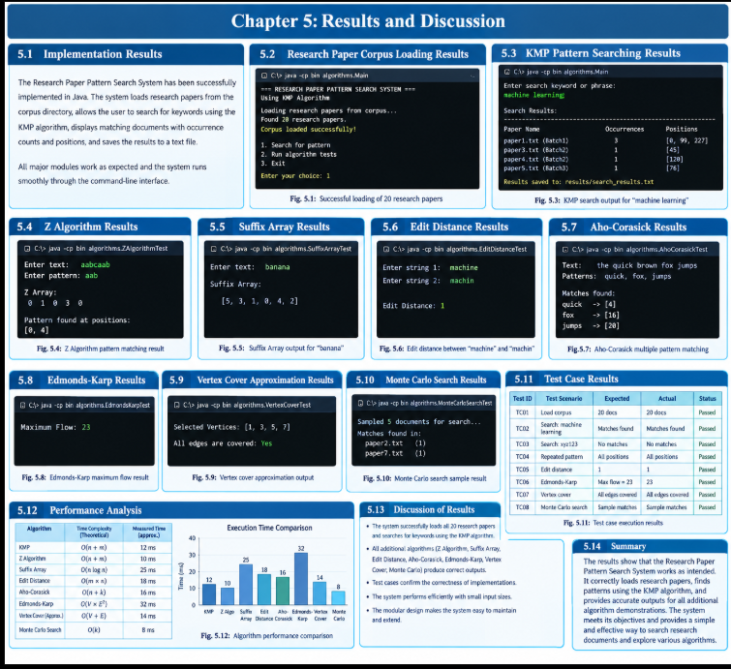

Screenshot 1: Implementation Results
This screenshot shows the successful execution of the Research Paper Pattern Search System in Java. The application loads 20 research papers, accepts a keyword, displays matching documents with occurrence counts and positions, and saves the search results to a text file.

Screenshot 2: Research Paper Corpus Loading Results
This screenshot demonstrates the loading of research paper text files from the corpus directory. The system reads the documents stored in different batches and confirms that the research papers have been loaded successfully for searching.

Screenshot 3: KMP Pattern Searching Results
This screenshot illustrates the working of the Knuth-Morris-Pratt (KMP) algorithm. When the user enters a keyword such as “machine learning,” the system identifies matching documents and displays the number of occurrences and their positions.

Screenshot 4: Z Algorithm and Suffix Array Results
This screenshot presents the outputs of the Z Algorithm and Suffix Array implementations. The Z Algorithm identifies pattern occurrences in a text, while the Suffix Array organizes suffix positions to demonstrate an alternative approach to string processing.

Screenshot 5: Edit Distance and Aho-Corasick Results
This screenshot demonstrates two string-processing algorithms. Edit Distance calculates the minimum number of operations required to transform one string into another, while Aho-Corasick searches for multiple patterns within a text.

Screenshot 6: Edmonds-Karp, Vertex Cover, and Monte Carlo Results
This screenshot presents the results of three additional algorithm demonstrations. Edmonds-Karp calculates the maximum flow in a network, Vertex Cover selects vertices to cover graph edges, and Monte Carlo Search randomly samples documents to look for a specified keyword.

Screenshot 7: Test Case Results and Performance Analysis
This screenshot summarizes the system's testing and performance evaluation. It presents test scenarios, expected and actual outputs, and algorithm performance comparisons, helping assess correctness and identify differences between the implemented approaches.

6.1 CHALLENGES, SOLUTIONS AND LIMITATIONS

6.1 Issues Faced During Development
During the development of the Research Paper Pattern Search System Using String Matching Algorithms, several challenges were encountered while implementing the algorithms, managing research paper files, and validating the search results.
1. Corpus File Management: Organizing and loading multiple research paper text files from different folders was a challenge. The system needed to locate the files correctly and process the documents stored in different batches.
2. Pattern Matching Accuracy: Implementing the Knuth-Morris-Pratt (KMP) algorithm required careful handling of pattern comparisons and the construction of the Longest Prefix Suffix (LPS) array. Errors in these steps could produce incorrect matching positions.
3. File Path Handling: Incorrect directory paths could prevent the application from finding research paper files. The project required a consistent folder structure and correct file path configuration.
4. Integration of Multiple Algorithms: Implementing and testing KMP, Z Algorithm, Suffix Array, Edit Distance, Aho-Corasick, Edmonds-Karp, Vertex Cover, and Monte Carlo Search required separate testing because the algorithms solve different problems.
5. Result Display and Storage: Displaying matching document names, occurrence counts, and positions in a readable format required appropriate output formatting. Saving the search results to a text file also required correct file handling.
6. Testing and Validation: Each algorithm needed suitable test inputs and expected outputs to verify its correctness. Special cases, such as patterns that do not occur in a document or patterns that appear multiple times, also needed consideration.

6.2 Solutions Applied
Several solutions were applied to address the challenges encountered during development and improve the reliability and usability of the system.
1. Structured Corpus Organization: The research paper text files were organized into separate batches inside the corpus directory. This structure made the documents easier to manage and helped the application locate the input files systematically.
2. Correct KMP Implementation: The KMP algorithm was implemented using the LPS array to avoid unnecessary comparisons after a mismatch. The matching logic was tested with different text and pattern combinations to verify the reported positions.
3. Consistent File Paths: The project folders were organized consistently, and the application was executed from the appropriate project directory. The corpus and results directories were maintained separately to simplify file access and output storage.
4. Separate Algorithm Modules: Each algorithm was implemented in its own Java class, with separate test classes where applicable. This modular structure made it easier to identify errors, test individual algorithms, and maintain the source code.
5. Improved Result Presentation: Search results were formatted to display document names, occurrence counts, and matching positions clearly. The application also saves search output in a text file for later reference.
6. Algorithm Testing: Test cases were used to check the behavior of the implemented algorithms. For example, the Edmonds-Karp demonstration was tested using a sample network with an expected maximum flow of 23, while the string-matching algorithms were tested with sample texts and patterns.

6.3 Limitations of the System
Although the Research Paper Pattern Search System provides useful facilities for searching text-based research papers, it has certain limitations.
1. Text File Support: The current system primarily processes research papers stored as plain text files. It does not directly extract content from PDF or Word documents.
2. Command-Line Interface: The application uses a command-line interface rather than a graphical user interface. Users must interact with the program through terminal commands and menu options.
3. Basic Search Functionality: The main search functionality focuses on exact keyword or pattern matching using KMP. It does not provide advanced semantic search, meaning-based retrieval, or automatic ranking according to research relevance.
4. Case Sensitivity: Search behavior depends on the implementation of the string-matching logic. If case-insensitive searching is required, additional text normalization or case-conversion logic must be incorporated.
5. Limited Corpus Size: The current corpus contains 20 research paper text files. Although it is suitable for demonstrating the system, larger collections would be required to evaluate scalability under realistic research workloads.
6. Limited Search Interface: The system does not currently provide advanced filtering by author, publication year, journal, or research domain through a complete metadata-based interface.
7. Separate Algorithm Demonstrations: Algorithms such as Z Algorithm, Suffix Array, Edit Distance, Aho-Corasick, Edmonds-Karp, Vertex Cover, and Monte Carlo Search are implemented as separate demonstrations. They are not all integrated into the main KMP-based research paper search process.
8. Randomized Search Limitation: The Monte Carlo Search demonstration examines a randomly selected subset of documents. Therefore, it may miss matching documents that are not included in the selected sample.
9. No External API Integration: The current implementation does not retrieve publication information from external research databases or APIs. The corpus must be prepared and maintained locally.
10. Limited Performance Evaluation: The current implementation demonstrates algorithm behavior using sample inputs and a limited corpus. Extensive benchmarking on large datasets would be necessary to establish reliable real-world performance comparisons.
Despite these limitations, the system successfully demonstrates the use of string-matching and other data structure and algorithm techniques for research paper text processing. Future enhancements could include PDF extraction, a graphical interface, metadata-based filtering, relevance ranking, larger datasets, and integration with external research publication services.

7.1 CONCLUSION AND FUTURE ENHANCEMENTS

7.1 Conclusion
The Research Paper Pattern Search System Using String Matching Algorithms was developed to simplify the process of searching for specific keywords and patterns within a collection of research paper text files. The system uses Java programming and Data Structures and Algorithms (DSA) concepts to identify matching patterns and display the corresponding research documents.
The main search functionality is implemented using the Knuth-Morris-Pratt (KMP) algorithm, which efficiently searches for a given pattern by avoiding unnecessary character comparisons. The system loads research papers organized into different batches, searches for user-provided keywords, displays matching document names, occurrence counts, and positions, and stores the search results in a text file.
In addition to KMP, the project includes separate implementations and demonstrations of the Z Algorithm, Suffix Array, Edit Distance, Aho-Corasick, Edmonds-Karp, Vertex Cover, and Monte Carlo Search. These implementations provide practical experience with string processing, graph algorithms, approximation techniques, and randomized search.
The project helped demonstrate how algorithmic techniques can be applied to text processing and document retrieval. Testing the individual implementations also helped improve the understanding of algorithm correctness and modular programming. Although the current system has limitations, such as plain-text file support and a command-line interface, it provides a foundation for developing a more advanced research paper retrieval application.
Overall, the project achieved its primary objective of creating a functional keyword-based research paper search system while providing practical experience in Java programming, algorithm implementation, file handling, testing, and software development.

7.2 Future Work
The Research Paper Pattern Search System can be improved in several ways to make it more useful, scalable, and convenient for researchers and students.
1. Graphical User Interface: A graphical interface can be developed to allow users to enter keywords, browse documents, and view search results without using the command line.
2. PDF and Word Document Support: The system can be enhanced to extract text from PDF and Microsoft Word documents, reducing the need to convert research papers into plain-text files manually.
3. Advanced Search Filters: Additional filters can be introduced to search research papers by title, author, publication year, keywords, and research domain. This would require storing and managing suitable metadata.
4. Semantic Search: Natural Language Processing (NLP) techniques and embedding-based retrieval can be introduced to identify documents related to a user's query even when they do not contain the exact search words.
5. Search Result Ranking: A relevance-ranking mechanism can be developed to display the most useful documents first based on factors such as keyword frequency, term relevance, and metadata.
6. Larger Research Corpus: The system can be tested with a larger collection of research papers to evaluate its scalability, search performance, and memory requirements.
7. Algorithm Comparison: The implemented string-matching algorithms can be evaluated using common datasets and controlled test conditions to compare execution time, memory usage, and suitability for different search tasks.
8. External Research Database Integration: APIs from research publication services can be integrated to retrieve publication metadata and expand the local corpus, subject to the services' access rules and limitations.
9. Improved Search History: Search history can be extended to store previous queries, matching documents, timestamps, and result summaries so that users can revisit earlier searches.
10. Improved Validation and Error Handling: More checks can be introduced for empty queries, missing directories, unreadable files, and invalid input. This would make the system more robust and easier to use.
These improvements could transform the current project into a more comprehensive research paper retrieval platform suitable for academic use.

7.3 Skills Learned During Development
The development of the Research Paper Pattern Search System provided practical experience in programming, algorithm design, software organization, and problem-solving.
1. Java Programming: Improved understanding of Java syntax, classes, methods, arrays, loops, conditional statements, and object-oriented programming concepts.
2. String-Matching Algorithms: Gained practical knowledge of KMP, the Z Algorithm, Suffix Array, Edit Distance, and Aho-Corasick, including their working principles and applications.
3. Data Structures and Algorithms: Learned how algorithm selection affects the efficiency of searching and processing text, and gained exposure to graph algorithms, approximation techniques, and randomized search.
4. File Handling: Developed skills in reading research paper text files, organizing document collections, managing file paths, and writing output to result files.
5. Modular Programming: Learned to separate the application into individual classes and modules, making the code easier to test, debug, understand, and maintain.
6. Testing and Debugging: Gained experience in preparing test cases, checking expected and actual outputs, identifying errors, and correcting implementation problems.
7. Problem-Solving Skills: Improved the ability to break a complex problem into smaller tasks, select appropriate algorithms, and develop step-by-step solutions.
8. Command-Line Execution: Learned to compile Java source files using javac, execute programs using java, and manage project files through the terminal and development environment.
9. Result Analysis: Learned to interpret matching positions, occurrence counts, algorithm outputs, and test results to evaluate whether an implementation behaves as expected.
10. Project Organization and Documentation: Gained experience in maintaining a structured project directory, documenting source code and functionality, preparing report sections, and organizing implementation evidence.
11. Version Control: Developed an understanding of Git and GitHub for tracking source-code changes, managing repositories, and sharing project work.
12. Technical Communication: Improved the ability to explain algorithms, describe implementation decisions, document challenges and solutions, and present technical results in a structured project report.
In conclusion, the project strengthened both programming knowledge and practical software development skills. It also provided a clearer understanding of how Data Structures and Algorithms can be used to solve real-world text-searching problems and how systematic testing contributes to reliable software.

REFERENCES

1. Books
Thomas H. Cormen, Charles E. Leiserson, Ronald L. Rivest, and Clifford Stein, Introduction to Algorithms, MIT Press. Reference for algorithm design, graph algorithms, and string matching.
Robert Sedgewick and Kevin Wayne, Algorithms, 4th Edition, Addison-Wesley. Reference for fundamental algorithms, data structures, and algorithm analysis.
Donald E. Knuth, James H. Morris Jr., and Vaughan R. Pratt, “Fast Pattern Matching in Strings,” SIAM Journal on Computing, 1977. Reference for the Knuth-Morris-Pratt pattern-matching algorithm.

2. Tutorials and Learning Resources
Oracle, The Java Tutorials — https://docs.oracle.com/javase/tutorial/
GeeksforGeeks, String Matching and Data Structures and Algorithms Tutorials — https://www.geeksforgeeks.org/
VisualStudioCode,JavainVisualStudioCode https://code.visualstudio.com/docs/languages/java

3. APIs and Official Documentation
Oracle, Java Platform Documentation — https://docs.oracle.com/en/java/
Oracle,JavaSEAPIDocumentation — https://docs.oracle.com/en/java/javase/17/docs/api/
OpenJDK,JavaCompiler(javac)Documentation — https://docs.oracle.com/en/java/javase/26/docs/specs/man/javac.html
GitHub, GitHub Documentation — https://docs.github.com/

4. Algorithm Reference Websites
National Institute of Standards and Technology (NIST), Dictionary of Algorithms and DataStructures:Knuth-Morris-PrattAlgorithm — https://www.nist.gov/dads/HTML/knuthMorrisPratt.html
SIAM, Fast Pattern Matching in Strings — https://doi.org/10.1137/0206024

5. Development Tools
Java Development Kit (JDK) — Used to compile and execute Java programs.
Visual Studio Code — Used to write, organize, and debug the project source code.
Git and GitHub — Used for source-code version control and repository management.
Windows PowerShell / Terminal — Used to compile programs, execute algorithms, and verify outputs.

